HANOI UNIVERSITY OF SCIENCE AND TECHNOLOGY

School of Information and communications technology

An Internet Media Store

Subject: Software Design and Development

Prepared by: Nguyen Duc Quyen

Student ID: 20183617

*Hanoi, $5^{th}$ October 2021*

*<All notations inside the angle bracket are not part of this document, for its purpose is for extra instruction. When using this document, please erase all these notations and/or replace them with corresponding content as instructed>*

*<This document, written by Asst. Prof. NGUYEN Thi Thu Trang, is used as a case study for student with related courses. Any modifications and/or utilization without the consent of the author is strictly forbidden>*

**Table of contents**

**Introduction** **2**

Objective 3

Scope 3

Glossary 3

References 4

**Overall Description** **4**

Survey 5

Use case diagrams 5

Business process 7

**Use case specification** **7**

Use case “Place Order” 8

Use case “Pay Order” 12

Use case “Place Rush Order” 14

**Activity diagrams** **18**

Use case “Place Order” 18

Use case “Pay Order” 19

Use case “Place Rush Order 19

# Introduction

*<The following subsections of the Software Requirements Specifications (SRS) document should provide an overview of the entire SRS. The thing to keep in mind as you write this document is that you are telling what the system must do – so that designers can ultimately build it. Do not use this document for design!!!>*

## Objective

<*Identify the purpose of this SRS and its intended audience. In this subsection, describe the purpose of the particular SRS and specify the intended audience for the SRS*>

## Scope

<*In this subsection:*

1. *Identify the software product(s) to be produced by name*
2. *Explain what the software product(s) will, and, if necessary, will not do*
3. *Describe the application of the software being specified, including relevant benefits, objectives, and goals*
4. *Be consistent with similar statements in higher-level specifications if they exist*

*This should be an executive-level summary. Do not enumerate the whole requirements list here*>

## Glossary

*<Listing and explaining the terms appearing in the software’s profession and this documents. Any assumption of the reader’s prior knowledge or experience on the subject is ill advised>*

| **No** | **Term** | **Explanation** | **Example** | **Note** |
| --- | --- | --- | --- | --- |
| **1** | token | A piece of data created by server, and contains the user's information, as well as a special token code that user can pass to the server with every method that supports authentication, instead of passing a username and password directly. | JSON Web Token (JWT) | Compact, URL-safe and usable especially in web browser single sign-on (SSO) context. |
| **2** | … |  |  |  |

## References

*<Listing the referenced material used in this documents, including the one related to the project>*

# Overall Description

< *Describe the general factors that affect the product and its requirements. This section does not state-specific requirements. Instead, it provides a background for those requirements, which are defined in section 3, and makes them easier to understand*. *In a sense, this section tells the requirements in plain English for the consumption of the customer. Section 3 will contain a specification written for the developers*>

## Survey

The system of AIMS consists of the following actors:

* Guest: Customers who are interested in the products in the shop but have yet to sign up for an account. Guests can see the list of products, create orders, and provide information for their payments.
* User: Guests who have signed up and had an account. Users are similar to guests, except they can use the default information included in their accounts for their payments.
* Admin: Special users who have total access to the system. They can add, block or unblock any other user, change their passwords and information. All of their activities, which involve other accounts, will be informed to the corresponding users.

## Use case diagrams

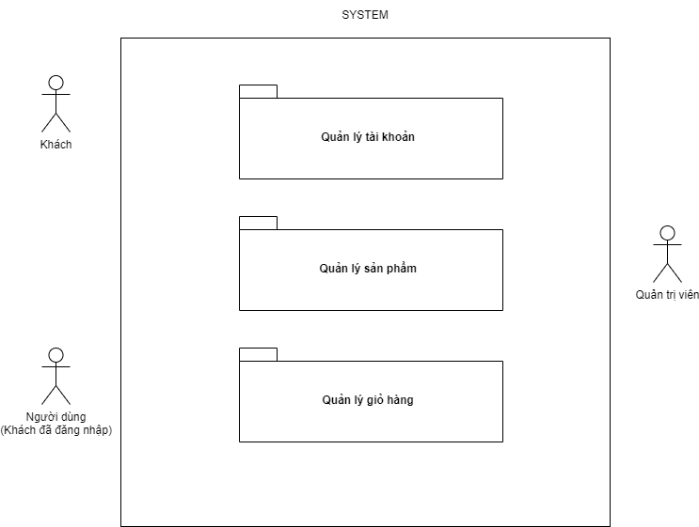

**Fig 1. Use-case packages**

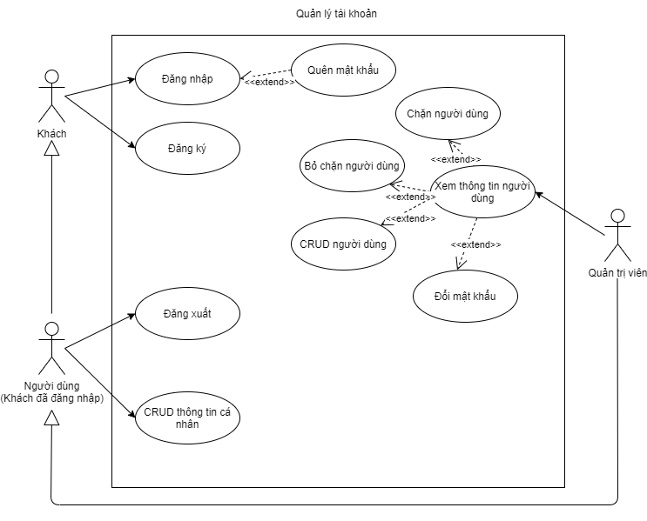

**Fig 2. Use-case diagram for the “Account management” package**

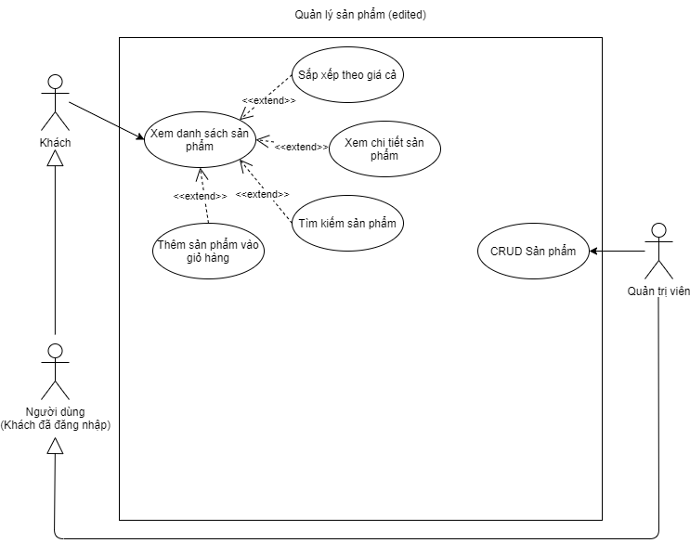

**Fig 3. Use-case diagram for the “Product management” package**

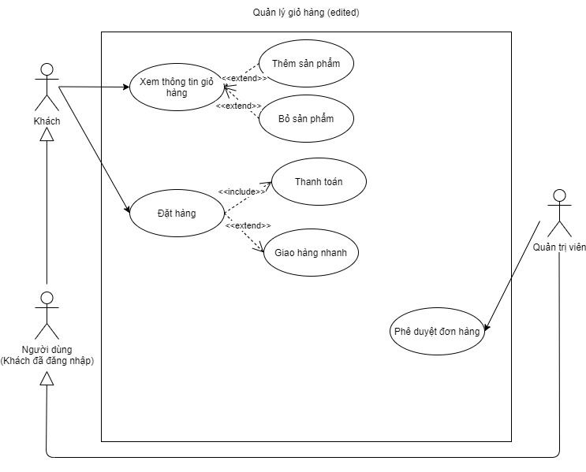

**Fig 4. Use-case diagram for the “Payment management” package**

## Business process

# Use case specification

## Use case “Place Order”

* + 1. **Use case code**

UC001

* + 1. **Brief description**

In the AIMS system, the UC001 - “Place Order” describes the interaction between customers and the AIMS software when they want to place orders.

* + 1. **Actors**
* Guests
* Users
  + 1. **Preconditions**
    2. **Basic Flow of Events**

Step1. The customer views the cart.

Step2. The AIMS software checks the availability of products in the cart.

Step3. The AIMS software displays the cart.

Step4. The customer requests to place the order.

Step5. The AIMS software displays the form of delivery information.

Step6. The customer enters and submits the delivery information.

Step7. The AIMS software calculates the shipping fees

Step8. The AIMS software displays the invoice.

Step9. The customer confirms to place the order.

Step10. The AIMS software calls UC002 - “Pay Order”.

Step11. The AIMS software creates a new order.

Step12. The AIMS software makes the cart empty.

Step13. The AIMS software displays the successful order notification.

* + 1. **Alternative Flows**

| **No** | **Location** | **Condition** | **Action** | **Resume location** |
| --- | --- | --- | --- | --- |
| 1. | Step 3 | If there are media of which quantity in the stock is less than the ordered quantity. | * The AIMS software asks the customer to update the cart * The customer updates the cart | Resumes at Step 2 |
| 2. | Step 7 | If a mandatory field is left blank | * The AIMS software asks the customer to fill all the mandatory blank | Resumes at Step 5 |
| 3. | Step 7 | If the phone number is invalid | * The AIMS sơftware asks the customer to enter a valid phone number. | Resumes at Step 5 |
| 4. | Step 7 | If the customer chooses to place a rush order | * The AIMS software calls the UC003 - “Place Rush Order” | Resumes at Step 1 - UC003 |

**Table 1: Alternative flows of events for UC ”Place Order”**

* + 1. **Input Data**

| **No** | **Data fields** | **Description** | **Mandatory** | **Validcondition** | **Example** |
| --- | --- | --- | --- | --- | --- |
| 1. | Receiver  Name |  | Yes |  | Nguyen Duc Quyen |
| 2. | Phone  Number |  | Yes |  | 0793206960 |
| 3. | Province | Choose from a list | Yes |  | Hanoi |
| 4. | Address |  | Yes |  | 12/34 Nguyen Huy Tuong str, Thanh Xuan Trung district |
| 5. | Shipping  instructions |  | No |  |  |

**Table 2: Input data of delivery information**

* + 1. **Output Data**

| **No** | **Data fields** | **Description** | **Display format** | **Example** |
| --- | --- | --- | --- | --- |
| 1. | Title | Title of a media product |  | DVD Phim Spirited Away |
| 2. | Price | Price of the corresponding media  product | * Comma for the thousands separator * Positive integer * Right alignment | 123,000 |
| 3. | Quantity | Quantity of the corresponding  media | * Positive integer * Right alignment | 2 |
| 4. | Amount | Total money of the corresponding  media | * Comma for the thousands separator * Positive integer * Right alignment | 246,000 |
| 5. | Subtotal  Before VAT | The total price of products in the cart  before VAT | * Comma for the thousands separator * Positive integer * Right alignment | 2,106,000 |
| 6. | Subtotal | The total price of products in the cart  with VAT | 2,316,600 |
| 7. | Shipping fees |  | 30,000 |
| **8.** | Total | Sum of subtotal and shipping fees | 2,346,600 |
| 9. | Currency |  |  | VND |
| 10. | Name |  |  | Nguyen Duc Quyen |
| 11. | Phone number |  |  | 0793206960 |
| 12. | Province | Choose from a list |  | Hanoi |
| 13. | Address |  |  | 12/34 Nguyen Huy Tuong str, Thanh Xuan Trung district |
| 14. | Shipping instructions |  |  |  |

**Table 3: Output data of displaying invoice**

| **No** | **Data fields** | **Description** | **Display format** | **Example** |
| --- | --- | --- | --- | --- |
| 1. | Title | Title of a media product |  | DVD Phim Spirited Away |
| 2. | Price | Price of the corresponding media  product | * Comma for the thousands separator * Positive integer * Right alignment | 123,000 |
| 3. | Quantity | Quantity of the corresponding  media | * Positive integer * Right alignment | 2 |
| 4. | Amount | Total money of the corresponding  media | * Comma for the thousands separator * Positive integer * Right alignment | 246,000 |
| 5. | Subtotal  Before VAT | The total price of products in the cart before VAT | * Comma for the thousands separator * Positive integer * Right alignment | 2,106,000 |
| 6. | Subtotal | The total price of products in the cart after VAT | 2,316,000 |
| 7. | Currency |  |  | VND |

**Table 4: Output data of displaying cart**

* + 1. **Postconditions**

## Use case “Pay Order”

* + 1. **Use case code**

UC002

* + 1. **Brief description**

In the AIMS system, this use case describes the

* + 1. **Actors**
* Users
* Guests
* Interbank
  + 1. **Preconditions**

The customer has finished modifying the cart, and the system has calculated the total amount of money that the customer has to pay.

* + 1. **Basic Flow of Events**

Step1. The AIMS software displays the form of payment information.

Step2. The customer enters and submits the payment information.

Step3. The customer confirms the transaction.

Step4. The AIMS software transfers the payment request to the Interbank.

Step5. The Interbank processes the transaction

Step6. The AIMS software saves the transaction.

Step7. The AIMS software displays the successful transaction notification.

* + 1. **Alternative Flows**

| **No** | **Location** | **Condition** | **Action** | **Resume location** |
| --- | --- | --- | --- | --- |
| 1. | Step 2 | If a mandatory field is left blank | * The AIMS software asks the customer to fill all the mandatory blank | Resumes at Step 2 |
| 2. | Step 2 | If the card number is invalid | * The AIMS sơftware asks the customer to enter a valid card number | Resumes at Step 2 |
| 3. | Step 5 | If the card doesn’t exist | * The AIMS software displays the unsuccessful transaction notification | Resumes at Step 1 |
| 4. | Step 5. | If the customer cannot afford the cart (customer’s balance isn’t enough) | * The AIMS software displays the unsuccessful transaction notification | Resumes at Step 1 |

**Table 5: Alternative flows of events for UC ”Pay Order”**

* + 1. **Input Data**

| **No** | **Data fields** | **Description** | **Mandatory** | **Validcondition** | **Example** |
| --- | --- | --- | --- | --- | --- |
| 1. | Cardholder name |  | Yes |  | Nguyen Duc Quyen |
| 2. | Card number |  | Yes |  | 1234-5678-9101-1121 |
| 3. | Expiration date |  | Yes | Consist of the month and the last 2 digits of the year only | 11/23 |
| 4. | Security code |  | Yes |  | 1234 |

**Table 6: Input data of payment information**

* + 1. **Output Data**
    2. **Postconditions**

## Use case “Place Rush Order”

* + 1. **Use case code**

UC003

* + 1. **Brief description**

In the AIMS system, the UC001 - “Place Order” describes the interaction between customers and the AIMS software when they want to place rush orders.

* + 1. **Actors**
* Guests
* User
  + 1. **Preconditions**

The customer chooses to place a rush order when filling in the delivery information

* + 1. **Basic Flow of Events**

Step1. The AIMS software check whether the products and customer’s address satisfy the conditions for placing a rush order.

Step2. The AIMS software displays the additional form for rush delivery.

Step3. The customer enters and submits the additional form.

Step4. The AIMS calculate the new shipping fees

Step5. The AIMS software displays the invoice.

Step6. The customer confirms to place the order.

Step7. The AIMS software calls UC002 - “Pay Order”.

Step8. The AIMS software creates a new order.

Step9. The AIMS software makes the cart empty.

Step10. The AIMS software displays the successful order notification.

* + 1. **Alternative Flows**

| **No** | **Location** | **Condition** | **Action** | **Resume location** |
| --- | --- | --- | --- | --- |
| 1. | Step 1 | If the cart’s and customer’s information doesn’t satisfy the constraints | * The AIMS software informs the customer and asks the customer to update the delivery form | Resumes at Step 1 |
| 2. | Step 4 | If a mandatory field is left blank | * The AIMS software asks the customer to fill all the mandatory blank | Resumes at Step 4 |
| 3. | Step 4 | If the phone number is invalid | * The AIMS sơftware asks the customer to enter a valid phone number | Resumes at Step 4 |

**Table 7: Alternative flows of events for UC ”Place Rush Order”**

* + 1. **Input Data**

| **No** | **Data fields** | **Description** | **Mandatory** | **Validcondition** | **Example** |
| --- | --- | --- | --- | --- | --- |
| 1. | Receiver  Name |  | Yes |  | Nguyen Duc Quyen |
| 2. | Phone  Number |  | Yes |  | 0793206960 |
| 3. | Province | Choose from a list | Yes |  | Hanoi |
| 4. | Address |  | Yes |  | 12/34 Nguyen Huy Tuong str, Thanh Xuan Trung district |
| 5. | Shipping  instructions |  | No |  |  |
| 6. | Expected date |  | Yes |  | Ship before 10/10/2021 |

**Table 8: Input data of rush delivery information**

* + 1. **Output Data**

The output forms are similar to those were specified in the UC001 - “Place Order

* + 1. **Postconditions**

# Activity diagrams

## Use case “Place Order”

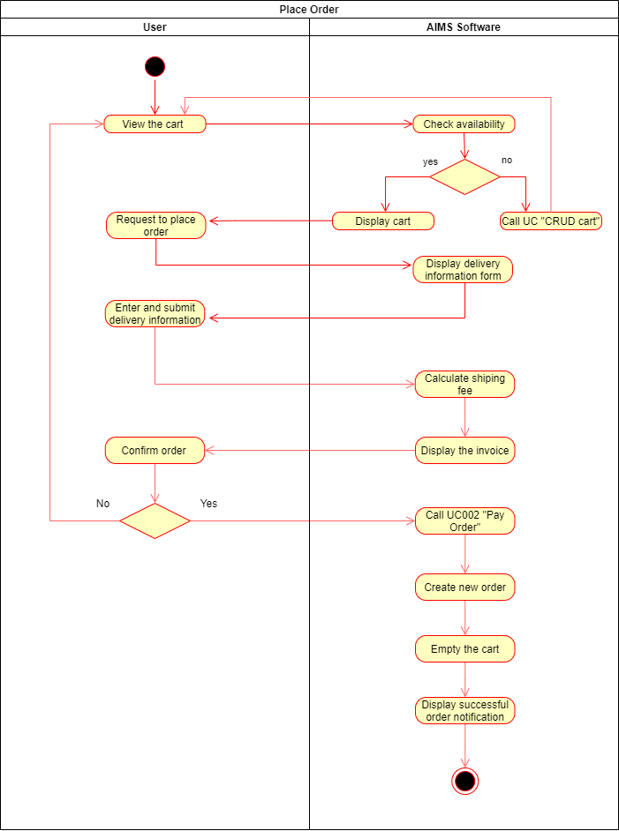

**Fig 5. Activity diagram for the use case UC001 - “Place Order”**

## Use case “Pay Order”

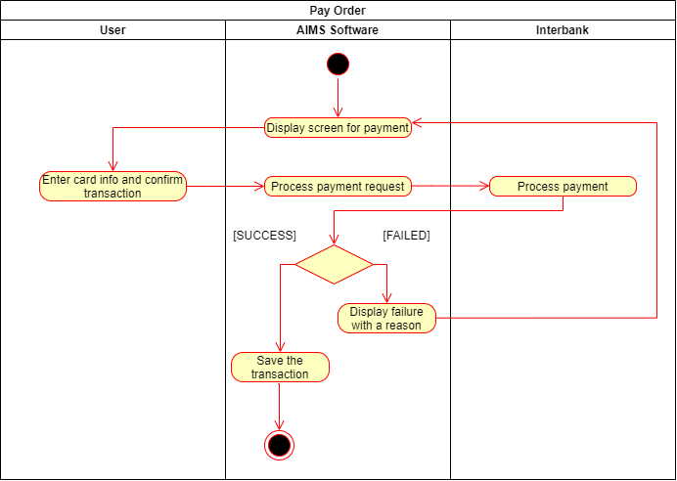

**Fig 6. Activity diagram for the use case UC002 - “Pay Order”**

## Use case “Place Rush Order

# 

**Fig 7. Activity diagram for the use case UC003 - “Place Rush Order”**